Smart Society Network System

Submitted By

Student Name | Student ID
Md. Talim Afrid Tomal | 0242310005101319
Nafish Imtiaz Imti | 0242310005101930
Jannat Akter Duli | 0242310005101917
Md Sajid Islam | 0242310005101579
Emon Kumer Sarkar | 0242310005101548

MINI LAB PROJECT REPORT
This Report Presented in Partial Fulfillment of the course
CSE322: Computer Networks Lab in the Computer Science and Engineering Department



DAFFODIL INTERNATIONAL UNIVERSITY
Dhaka, Bangladesh
April 16, 2025

DECLARATION
We hereby declare that this lab project has been done by us under the supervision of Mr. Amir Sohel, Lecturer (Senior Scale), Department of Computer Science and Engineering, Daffodil International University. We also declare that neither this project nor any part of this project has been submitted elsewhere as lab projects.

Submitted To:


Mr. Amir Sohel (ARS)
Senior Lecturer
Department of Computer Science and Engineering Daffodil International University

Submitted by



Md. Talim Afrid Tomal
ID:0242310005101319
Dept. of CSE, DIU
  Nafish Imtiaz Imti  ID: 0242310005101930  Dept. of CSE, DIU |   Jannat Akter Duli  ID: 0242310005101917  Dept. of CSE, DIU
  Md. Sajid Islam  ID:0242310005101579  Dept. of CSE, DIU |   Emon Kumer Sarker  ID:0242310005101548  Dept. of CSE, DIU

COURSE & PROGRAM OUTCOME

Table 1: Course Outcome Statements
CO’s | Statements
CO1 | Understand the basic knowledge of networking fundamentals, economic factors, and simulation tools for modern communication system.
CO2 | Analyze an adaptable approach to network configuration and optimization by analyzing IP address allocation, evaluating current and emerging communication protocols to configure routers, switches, and servers.
CO3 | Design diverse network topologies and routing protocols using Packet Tracer through collaborative projects and presentations, effectively communicate technical decisions and justifications regarding network optimization.

Table 2: Mapping of CO, PO, Blooms, KP and CEP
CO | PO | Blooms | KP | CEP | CEA
CO1 | PO5 | C2 | KP4 | EP1 | EA1
CO2 | PO2 | C3, P3 | KP3 | EP2 | EA2
CO3 | PO2 | P2, A2 | KP8 | EP4 | EA4

The mapping justification of this table is provided in section 4.3.1, 4.3.2 and 4.3.3.

Table of Contents

Declaration i

Course & Program Outcome ii
- Introduction 1
  - Introduction 1
  - Motivation 1
  - Objectives 2
  - Feasibility Study 2
  - Gap Analysis 3
  - Project Outcome 4
- Proposed Methodology/Architecture 2
  - Requirement Analysis & Design Specification 5
    - Overview 5
    - Proposed Methodology/ System Design 5
    - UI Design 6
  - Overall Project Plan 6
- Implementation and Results 8
  - Implementation 8
  - Performance Analysis 9
  - Results and Discussion 9
- Engineering Standards and Mapping 10
  - Impact on Society, Environment and Sustainability 10
    - Impact on Life 10
    - Impact on Society & Environment 10
    - Ethical Aspects 10
    - Sustainability Plan 10
  - Project Management and Cost Analysis & Team Tasks 11
  - Complex Engineering Problem 13
    - Mapping of Program Outcome 13
    - Complex Problem Solving 13
    - Engineering Activities 14

Table of Contents Table of Contents
- Conclusion 15
  - Summary 15
  - Limitation 15
  - Future Work 16
References 17

Chapter 1

Introduction

Introduction

In the age of digital transformation and rapidly advancing communication technologies, the concept of a connected living environment has become more than a futuristic vision—it is a practical and necessary step toward enhancing the efficiency, security, and sustainability of modern communities. Traditional residential areas often lack centralized control, automated monitoring, and seamless communication between essential services. As cities grow smarter, the need for a unified networking system within societies becomes increasingly vital.

The project titled Smart Society Network System addresses this need by designing a comprehensive and structured communication infrastructure for a residential community. The system aims to interconnect smart homes, security surveillance units, and public service zones like parks and gardens, ensuring smooth data flow, centralized control, and automated services across all segments. Each home is equipped with IoT-based appliances such as smart lights, fans, and automated doors, while the security segment features wireless CCTV cameras, servers, and monitoring PCs. In public areas, the system integrates smart devices like water-level-based sprinklers and provides internet access through public Wi-Fi zones.

Built using networking principles such as VLAN segmentation, DHCP, static routing protocols, the system offers not only connectivity but also a high level of scalability, security, and performance optimization. The use of Cisco Packet Tracer for simulation ensures practical feasibility and hands-on validation of real-world networking scenarios.

By creating a networked community infrastructure, this project not only promotes automation and convenience but also highlights the application of core computer networking concepts in solving contemporary challenges. The Smart Society Network System serves as a model for future-ready digital societies, where every device, every service, and every resident is seamlessly connected for a smarter and more efficient living experience.

Motivation

Advancements in technology have led to the emergence of smart communities that aim at improving the overall living standards of citizens and the functioning of metropolitan infrastructures. The goal of this project is to create a holistic networking model for a modern residential society that includes houses, administrative offices, and public amenities. Using advanced networking concepts of VLAN, DHCP, NAT, and different routing protocols, this project will showcase the benefits of integrating sophisticated wireless network designs that offer automation, surveillance, and centralized command capabilities. The essence of the project is to conceptualize automation theoretical basics and showcase the challenges posed in smart cities and societies.

Objective

Design a Scalable Network

Develop a network infrastructure capable of connecting residential homes, Surveillance office, and public facilities within a smart community

Implement VLAN Segmentation

Utilize VLANs to separate various services (such as home automation, security, and park garden) to enhance both performance and security.

Integrate Core Network Services

Set up DHCP for dynamic IP addressing, NAT for internet connectivity to ensure efficient data transmission.

Enable Smart Home Automation

Facilitate the connection and management of IoT devices (like smart lights, fan, ac, Furnace thermostats and doors) in each household by applying networking principles.

Simulate Real-World Network Communication

Utilize Cisco Packet Tracer to evaluate network connectivity, routing, IP assignments, and device interactions within the smart community.

Feasibility Study

Several research studies and existing technological implementations indicate the growing significance and feasibility of smart society networks. Similar works have shown both practical value and technical viability in integrating smart home automation, surveillance systems, and IoT-based environmental controls into unified network architectures.
- Smart Home Systems
Numerous smart home platforms like Google Home, Amazon Alexa, Samsung SmartThings and Apple Home kit provide integrated control over lighting, security, and appliances through Wi-Fi. Research studies show that implementing VLANs and IoT protocols within residential networks enhances both performance and security.
- Security Surveillance Systems
In smart cities, centralized surveillance with IP cameras, motion detection, and remote storage is commonly used. Projects like Safe City initiatives in places like Singapore and Dubai have successfully implemented similar surveillance systems integrated over a dedicated VLAN for high-priority traffic. Tools like ZoneMinder and Blue Iris are open-source software examples that show how video surveillance can be centrally managed and remotely accessed.
- Smart Irrigation in Parks/Gardens
IoT-based sprinkler systems like RainMachine, Rachio, and Xiaomi’s Mi Water Saver use environmental data (e.g., soil moisture or water level sensors) to control watering schedules efficiently. Academic case studies have demonstrated how sensor-based automation reduces water wastage and allows remote monitoring through web/mobile dashboards.
- Methodological Contribution
This project adopts a segmented VLAN-based network design to isolate and efficiently manage traffic for smart homes, surveillance, and garden IoT. Unlike existing systems that operate as standalone entities, this project proposes an integrated structure using DHCP, NAT, and static routing, providing real-time responsiveness, centralized monitoring, and IoT automation across diverse services.

Gap Analysis
- Lack of Unified Network Infrastructure
Many smart systems do not share a common network backbone. This leads to inefficient resource usage, increased cost, and difficulties in centralized management.
- Insufficient Use of VLAN Segmentation in Community Settings
While VLANs are widely used in enterprise networks, they are rarely applied in smart residential or mixed-use community projects for separating traffic between homes, security, and public utilities.
- Limited Real-time Monitoring and Control
Existing systems often lack real-time interaction between segments. For example, a home user cannot monitor surveillance footage or water usage in the community garden due to poor network planning or integration.
- Scalability and Customization Challenges
Many commercial solutions are vendor-locked or difficult to scale across a growing smart community, making it hard for administrators to manage changes or expand coverage without re-engineering the system.
- Absence of Educational/Prototype Models for Learning Purposes
There's a lack of simplified, yet fully-featured prototypes or simulations (like in Cisco Packet Tracer) for students and developers to experiment with smart society-level designs that incorporate routing, VLANs, IoT devices, and automation.

Project Outcome
- Fully Functional Smart Network Simulation
A comprehensive network model that seamlessly connects smart homes, administrative security surveillance, and public facilities like park_garden, ensuring efficient data communication and service delivery.
- Hands-On Application of Networking Concepts
Gained practical experience in configuring VLANs, routing protocols, DHCP, and NAT within a complex, multi-layered environment.
- Centralized Management and Automation
Achieved efficient centralized control over devices, services, and IP address allocation, along with the automation of smart home and public service operations.
- Enhanced Security Implementation
Successfully implemented access control lists (ACLs), VLAN isolation, and NAT to secure internal communications and manage external access.
- Improved Understanding of Smart Society Infrastructure
Developed a deeper insight into how smart technologies and networking can collaborate to create the foundation for future smart cities and communities.
- Simulation-Based Problem-Solving Skills
Strengthened abilities in network troubleshooting, simulation testing (including ping, traceroute, and routing table checks), and performance optimization using Cisco Packet Tracer.

Chapter 2

Proposed Methodology/Architecture

The Smart Society Network System is designed using a modular, segmented network architecture with VLAN-based separation and inter-VLAN routing to ensure scalability, security, and efficiency.
The methodology involves building and simulating an integrated smart environment using Cisco Packet Tracer, where multiple devices and services communicate over a logically structured network.

Requirement Analysis & Design Specification

Overview

Smart society will have:

Residential Homes (each house has smart appliances and IoT devices).

Security Surveillance Office (street cameras, a central security system with a DHCP server, database).

Public Facilities (e.g., parks, Smart Sprinkle using water level).

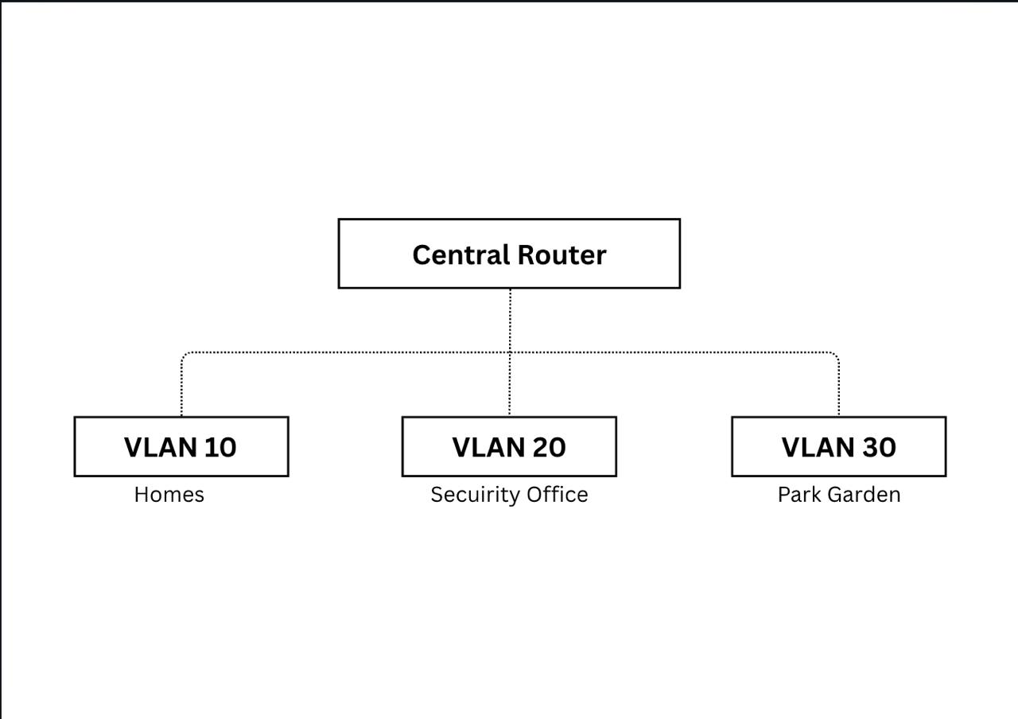
Proposed Methodology/System Design
Figure 2.1: This is a sample diagram of distributed network plan

UI Design

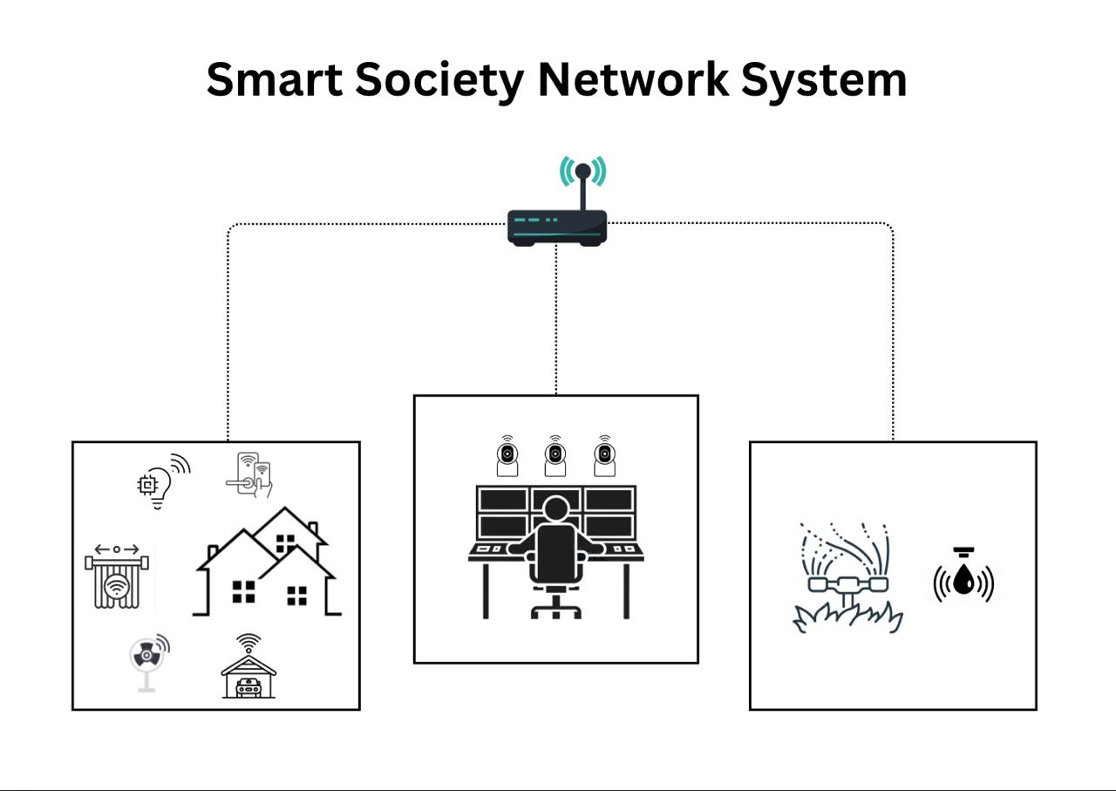
VLAN 20 (Security Surveillance)
VLAN 10 (Smart Home)
VLAN 30 (Park_Garden)
Figure 2.2: This is the preliminary user interface

Overall Project Plan

The project plan outlines the development phases, objectives, and tasks involved in building the Smart Society Network System using Cisco Packet Tracer. The plan ensures timely execution of design, simulation, testing, and documentation components.

Project Objectives:

Design a VLAN-segmented smart society network

Integrate smart home devices, surveillance systems, and garden automation

Configure DHCP, NAT, static and dynamic routing.

Simulate real-time communication and control of all devices

Ensure centralized monitoring and scalability

Produce detailed documentation and diagrams for the entire system

Project Timeline (Phases and Tasks):
Phase | Timeline | Key Activities
Phase 1: Planning & Research | Week 1 | - Finalize project scope  - Identify components (homes, surveillance, park)  - Research on similar systems (for feasibility study)
Phase 2: Network Design | Week 2 | - Create base topology in Cisco Packet Tracer  - Assign VLANs (10, 20, 30) to switches  - Plan IP addressing scheme
Phase 3: Routing & DHCP Setup | Week 3 | - Configure routing  - Implement router-on-a-stick  - Set up DHCP for each VLAN
Phase 4: IoT Device Integration | Week 4 | - Add smart lights, fans, doors, AC, etc. in homes  - Add cameras and server in surveillance  - Add water-level sensor and sprinkler in garden
Phase 5: Automation & Control Setup | Week 5 | - Program automation scripts  - Set control access via mobile in Packet Tracer
Phase 6: Testing & Troubleshooting | Week 6 | - Check communication across VLANs  - Validate DHCP and NAT  - Test all IoT responses
Phase 7: Documentation & Final Report | Week 7 | - Prepare architecture diagram  - Write feasibility study, methodology, gap analysis  - Compile screenshots and results  - Finalize report and presentation

Tools and Technologies

Cisco Packet Tracer – for simulation and IoT logic

PCs(PC-PT), Switches(2960), Routers(2911), Wireless Router(WRT300N), Home Gateway(DLC 100), Server(Server-PT), IoT Devices(Smartphone, door, light, fan, AC, Furnace, Garage, Motion Detector, Thermostat, Window, Appliance, Webcam, Lawn Sprinkler, Water level monitor) – Packet Tracer components

VLANs, NAT, DHCP – core network protocols

Deliverables

Fully simulated and working smart society network

Network architecture diagram

Configuration scripts for routers, switches

Screenshots of working automation

Project report with documentation (feasibility, methodology, gap analysis, conclusion)

Chapter 3

Implementation and Results

Implementation

Network Design
- Smart Homes
Each smart home have :
- IOT devices (Smartphone, door, light, fan, AC, Furnace, Garage, Motion Detector, Thermostat, Window, Appliance)
- A local Home Gateway which is connected to appliances.
- DHCP to assign IPs to home devices.
- Security Surveillance Office
- CCTV Network connected through Wireless connection using WRT300N.
- Server to store resident information.
- A central PC to view the feed of Camera’s.
- Park_Garden
- A Lawn Sprinkle is connected to home gateway with a pc
- Based on water level it’ll turn the sprinkle on

  - Routing Implementation
- DHCP: For interconnection of IoT devices.
- Static: Used for connect server with pc and cameras.

  - Addressing Scheme
- VLAN 10 - Home Automation (Smart appliances, IoT)
- VLAN 20 - Security & Surveillance (CCTV)
- VLAN 30 – Park_Garden (sprinkles)
- Test VLANs using different networks for each category.
- Verify DHCP for dynamic IP assignment.

Performance Analysis

The Smart Society Network System was analyzed based on the key performance metrics of a modern smart network: communication efficiency, latency, device accessibility, scalability, and reliability. The network was simulated in Cisco Packet Tracer and tested across all VLAN segments using smart IoT devices, routers, switches, and PC servers.

Communication Efficiency

Intra-VLAN communication (e.g., between smart home devices) showed seamless data transmission due to switch-level isolation.

Inter-VLAN communication was successfully established using Router-on-a-Stick with trunk links and static routing.

Device Accessibility

Devices in each VLAN successfully acquired IP addresses from the DHCP server, verifying dynamic IP management.

Security PCs accessed IP camera feeds; users could control smart devices via simulated dashboards.

Scalability

The VLAN-based architecture allowed the easy addition of new homes, sensors, or cameras.

Routing protocols like RIP/EIGRP ensured that new routes were auto-learned without reconfiguring the entire network.

Reliability and Redundancy

Static routing ensured consistent paths with no routing loops.

Resource Utilization

Optimized use of switch ports and logical VLANs minimized hardware redundancy.

Shared DHCP and NAT services reduced overhead and centralized control

Results and Discussion
Topic | Result | Discussion
Network Segmentation and Communication | Devices within each VLAN communicated effectively | VLAN segmentation provided clear isolation between segments while reducing unnecessary traffic, improving performance and manageability
DHCP Functionality | IoT devices successfully received dynamic IP addresses | Centralized DHCP simplified IP management and reduced manual errors.
IoT Device Automation | Smart fans, lights, doors etc. worked as expected and controlled by smartphone | Cisco Packet Tracer’s IoT simulation tools enabled realistic automation behavior.
Centralized Monitoring | The security PC could monitor live feeds of camera | This demonstrated the viability of centralized control in real-time smart societies, making the system both user-friendly and efficient.
System Scalability | New homes, cameras, and IoT devices were added with minimal config changes. | The VLAN-based modular design proved to be scalable and future-ready for expanding residential and security areas.

Chapter 4

Engineering Standards and Mapping

Impact on Society, Environment and Sustainability

Impact on Life

The project demonstrates how intelligent networking can elevate everyday living through advancements in home automation, public safety, and resource management. It embodies the future of interconnected communities, offering improved security, convenience, and centralized control.

Impact on Society & Environment

The project cultivates a smarter, safer, and more connected society by integrating technology into daily life, thereby improving communication, security, and convenience. Environmentally, it champions energy-efficient living through smart devices that lower power consumption and support sustainable urban development.

Ethical Aspects

While this offers numerous benefits, it also raises important ethical considerations, particularly related to privacy, data security, and responsible surveillance.

First and foremost, the system involves constant monitoring of residential areas through CCTV cameras and smart sensors. To ensure ethical use, it is crucial that surveillance is restricted to public and community-owned spaces, such as the security office and common areas, avoiding intrusion into private lives. Clear guidelines must be established regarding who has access to camera feeds and how long footage is retained.

Furthermore, the system collects and processes data from smart home devices and environment sensors. Ethical responsibility demands that such data be handled transparently and securely, with protections against misuse, unauthorized access, and data breaches. In real-world deployment, residents must be informed and give consent regarding the types of data collected and how it is used.

Sustainability Plan

Our Smart Society Networking System is built for long-term sustainability, utilizing energy-efficient IoT devices, centralized resource management, and a scalable network architecture. This initiative facilitates future upgrades, reduces energy consumption through automation, and fosters eco-friendly living by minimizing manual tasks and promoting smart energy usage in both homes and public facilities.

Project Management and Cost Analysis

Cost Analysis:
Component | Quantity | Unit Price  (BDT) | Total  (BDT) | Rationale
Cisco Switch (Layer 2/3) | 3 | 15,000 | 45,000 | For VLAN support
Cisco Router (2900 Series) | 1 | 30,000 | 30,000 | Routing across VLANs
IoT Smart Devices (Sensors, Lights, Doors) | 20+ | 2,000 | 40,000 | Smart control, home & garden
CCTV Cameras (IP) | 4 | 5,000 | 20,000 | Security surveillance
DVR/Server for CCTV | 1 | 20,000 | 20,000 | Storage and monitoring
Wireless Access Point | 2 | 5,000 | 10,000 | Public Wi-Fi in park
Cabling and Connectors | - | - | 10,000 | Network cabling
UPS/Power Backup System | 1 | 8,000 | 8,000 | Uninterrupted power
Installation and Configuration | - | - | 7,000 | Local technician labor
Total Estimated Cost |  |  | 190,000 | -

Alternate Low Cost for educational purpose:
Component | Quantity | Unit Price  (BDT) | Total  (BDT) | Rationale
Basic Switch (TP-Link/Unmanaged) | 3 | 3,000 | 9,000 | Basic VLAN with limited features
Basic Router (SOHO device) | 1 | 5,000 | 5,000 | Routing simulation only
Simulated IoT Devices (in PT) | - | - | 0 | Using Packet Tracer virtual devices
Dummy Cameras (for prototype) | 2 | 2,000 | 4,000 | Limited live feed setup
PC for Server Simulation | 1 (used) | 10,000 | 10,000 | Use old/refurbished PC
Cabling | - | - | 3,000 | Local materials
Configuration & Setup (Self) | - | - | 0 | Self-managed setup
Total Estimated Cost |  |  | 31,000 | -

Team and work distribution:
- Md. Talim Afrid Tomal (Project Manager)
Task: -Planned and supervised the entire project lifecycle
-Coordinated among team members and tracked progress
-Managed task distribution and deadlines
- Nafish Imtiaz Imti (Network Designer)
Task: - Designed and implemented the backend system using Cisco Packet Tracer
- Design the network
- Integrated modules and handled connectivity logic between networking devices
- Jannat Akter Duli (Analyzer & Designer)
Task: - Analyze similar type projects
-Gather the necessary resources
-Designed user interface layouts and pages
- Md. Sajid Islam (Quality Assurance)
Task: - Tested each module to identify bugs and performance issues
- Conducted functional and Time delay testing
- Ensured system met functional requirements
- Emon Kumer Sarkar (Documentation Specialist)
Task: - Prepared project reports, SRS, and design documents
- Documented each phase of development
- Assisted in final report writing and formatting

Complex Engineering Problem

Mapping of Program Outcome
Table 4.1: Justification of Program Outcomes
PO’s | Justification
PO1 | The project demonstrates fundamental networking concepts such as the use of wireless communication, DHCP for dynamic IP allocation, and static Routing for efficient data flow within different segments of the society. Additionally, simulation tools like Cisco Packet Tracer have been utilized to model and test the real-world feasibility of the network setup, allowing us to understand and apply economic and technical constraints while building scalable solutions.
PO2 | Throughout the project, we have analyzed and allocated IP addressing schemes, to ensure optimized communication between different VLANs and external networks. We configured and managed routers, switches, servers, and wireless access points to support the specific needs of smart homes, surveillance systems, and public utilities. By identifying communication bottlenecks and resolving configuration conflicts, we applied a problem-solving mindset that reflects real-world adaptability and optimization techniques
PO3 | The design of the multi-segment network topology using VLANs represents our ability to build structured, scalable, and secure communication infrastructures. We collaboratively designed the system to support automation in homes, smart sprinkler control in public areas, and efficient monitoring in the surveillance segment. Through presentations and documentation, we have clearly communicated technical decisions such as why certain routing protocols were selected, how automation reduces redundancy, and the impact of network design on social, cultural, and environmental aspects. This fosters responsible and impactful network design thinking.

Complex Problem Solving
Table 4.2: Mapping with complex problem solving.
EP1  Range of Conflicting Requirements | EP2  Depth of Analysis | EP4  Familiarity of Issues
The diverse expectations of stakeholders, limitations in technology, and trade-offs between performance, cost, and usability.  Page-8,9,10,11 | A multi-layered analysis that spans across network design, IoT integration, routing techniques, and practical implementation challenges, providing a comprehensive understanding of both the theoretical and applied aspects of modern smart community networking.  Page-5,6,7 | The project team encountered with a variety of technical, operational, and practical issues like server connection failed, limitations of Cisco to manipulate and preview all connectivity.  Page-9,15,16

Engineering Activities
Table 4.3: Mapping with complex engineering activities.
EA1  Range of resources | EA2  Level of Interaction | EA4  Consequences for society and environment
A wide range of engineering resources, covering both hardware(Routers and Switches, IoT devices, PC, Servers) and software components(Cisco Packet Tracer, Notepad for ip plan, Draw.io to design), as well as human expertise.  Page-7,8 | The level of interaction in this project is highly dynamic and multidimensional, combining machine-to-machine (M2M), human-to-machine (H2M), and system-to-system (S2S) communication.  Page-10 | Enhanced Safety and Security, Efficient Resource Management, Improved Quality of Life by automation, Promoting Technological Awareness.  Page-10

Chapter 5

Conclusion

The project simulates a smart society network by utilizing VLANs, routing, DHCP. It highlights the practical applications of networking, automation, and security within a connected community.

Summary

The Smart Society Networking System project is designed to create and simulate a fully interconnected modern residential community utilizing advanced networking technologies. It seamlessly integrates smart homes, a central administrative office, and public amenities such as parks and security systems within a structured network framework. Essential networking concepts, including VLAN, DHCP, NAT, and various routing protocols (Static, Dynamic), are employed to facilitate efficient communication, enhance security, and enable automation. Additionally, the system offers internet connectivity through an ISP cloud, centralized IP management, and IoT-driven home automation. This simulation serves as a practical illustration of how networking can foster the development of smart, secure, and efficient communities.

Limitation

While the Smart Society Network System is a good way to integrating smart home technologies, security surveillance, and environmental monitoring, it comes with certain limitations that must be addressed for real-world deployment. These limitations stem from both technical constraints and practical challenges.
- Simulation environment used for the project provides a limited representation of real-world systems. While it effectively simulates network configurations and basic IoT device interactions, it lacks the ability to fully replicate real life interactions. For instance, advanced features like cloud-based integration, real-time video streaming from cameras, or remote control of devices via mobile apps are not accurately represented in the simulation.
- Hardware dependency of the system presents another limitation. The project is highly reliant on Cisco and IOT devices. The actual cost, installation, and maintenance of these devices can be much higher than the estimated budget, particularly for larger installations or more sophisticated features.
- Scalability. While the network design supports adding new devices and expanding the system, the current design might face challenges as the system scales up significantly in terms of device count, traffic load, and data management. Issues like network congestion, performance degradation, or the need for more advanced routing protocols could arise, requiring additional infrastructure or upgrades.
- Security and privacy of data is a significant concern in smart networks. With the constant monitoring of homes and public spaces, it is crucial to protect sensitive data from unauthorized access. The system, in its current form, does not include robust security mechanisms such as end-to-end encryption, intrusion detection systems, or secure cloud storage, which are necessary for preventing potential data breaches and maintaining user privacy.

Future Work

Integration with Real-world IoT Devices

Currently, the system relies on simulated IoT devices within Cisco Packet Tracer. The next step involves integrating real-world IoT devices like smart thermostats, locks, cameras, and sensors.

Improved Network Security and Privacy

One of the key future focuses will be the implementation of robust security protocols to protect the network from potential cyber-attacks and unauthorized access. This includes:

End-to-end encryption for data transmission between devices and servers.

Intrusion Detection and Prevention Systems to monitor network traffic and detect malicious activity.

Secure cloud storage solutions for sensitive data such as CCTV footage. These improvements will ensure the system is secure and compliant with privacy regulations, protecting residents' personal information.

Scalability for Large-scale Deployments

While the current system works well for small to medium-sized environments, it may face challenges when scaling up to a larger number of homes or users. Future work will focus on:

Implementing more advanced routing protocols (e.g., OSPF, BGP) for better performance in larger networks.

Enhancing the network topology to support high traffic loads and complex communication between a growing number of devices.

Cloud Integration and Remote Access

To enhance usability, cloud-based platforms will be integrated, allowing users to access and control their devices remotely through mobile apps or web interfaces. This will allow for real-time monitoring and control, even from outside the home. Cloud integration will also provide benefits such as data backup, system analytics, and remote diagnostics.

Energy Efficiency and Sustainability

To make the system more energy efficient, low power and Bluetooth Low Energy(BLE) to increase efficiency.

References

[1] Computer Networking (A Top-Down approach), 6th Edition, by James F. Kurose and Keith Ross.
[2] Data Communication and Networking, 5th Edition, by Behrouz A Forouzan.
[3] Cisco.com>support
[4] Wikipedia.org

.

